10.7 Render - Workflows
Rendering Animations 1
Workflow 1
Frame Sequence Workflow 3
Hints 3
Command Line 4
Platforms 4
Linux 4
macOS 5
MS-Windows 5
Examples 5
Single Image 5
Animation 6
Multiview Introduction 6
Usage 7
Introduction 8
Views Setup 9
Camera 10
Viewport 10
Stereo 3D Display 11
OpenGL Preview 11
Rendering and UV/Image Editor 12
Image Formats 12
Final Considerations 13
Window Stereo 3D Display 13
Display Mode 13
Stereo 3D Camera 14
Convergence Mode 14
Viewport Stereo 3D 15
Multi-View and Stereo 3D Image I/O 16
Image Editor 17
Compositor 17

Rendering Animations

While rendering stills will allow you to view and save the image from the render buffer when it is complete, animations are a series of images, or frames, and are automatically saved directly out to a drive after being rendered.
After rendering the frames, you may need to edit the clips, or first use the Compositor to do green-screen masking, matting, color correction, DOF, and so on to the images. That result is then fed to the Sequencer where the strips are cut and mixed and a final overlay is done.
Finally you can render out from the Sequencer and compress the frames into a playable movie clip.

Workflow
Generally, you do a lot of intermediate renders of different frames in your animation to check for timing, lighting, placement, materials, and so on. At some point, you are ready to make a final render of the complete animation for publication.
There are two approaches you can use when making a movie, or animation, with or without sound. The approach you should use depends on the amount of CPU time you will need to render the movie. You can render a “typical” frame at the desired resolution, and then multiply by the number of frames that will ultimately go into the movie, to arrive at a total render time.
If the total render time is an hour or more, you want to use the “Frame Sequence” approach. For example, if you are rendering a one-minute video clip for film, there will be (60 seconds per minute) X (24 frames per second) or 1440 frames per minute. If each frame takes 30 seconds to render, then you will be able to render two frames per minute, or need 720 minutes (12 hours) of render time.
Rendering takes all available CPU time; you should render overnight, when the computer is not needed, or set Blender to a low priority while rendering, and work on other things (be careful with the RAM space!).
Direct Approach
The Direct Approach, which is highly not recommended and not a standard practice, is where you set your output format to an AVI or MOV format, and click Animation to render your scene directly out to a movie file. Blender creates one file that holds all the frames of your animation. You can then use Blender’s VSE to add an audio track to the animation and render out to an MPEG format to complete your movie.
Frame Sequence
The Frame Sequence is a much more stable approach, where you set your output format to a still format (such as JPG, PNG or MultiLayer), and click Animation to render your scene out to a set of images, where each image is a frame in the sequence.
Blender creates a file for each frame of the animation. You can then use Blender’s compositor to perform any frame manipulation (post processing). You can then use Blender’s VSE to load that final image sequence, add an audio track to the animation, and render out to an MPEG format to complete your movie. The Frame Sequence approach is a little more complicated and takes more drive space, but gives you more flexibility.
Here are some guidelines to help you choose an approach.
Direct Approach
- short segments with total render time < 1 hour
- stable power supply
- computer not needed for other uses
Frame Sequence Approach
- total render time > 1 hour
- post-production work needed
  - Color/lighting adjustment
  - Green screen/matte replacement
  - Layering/compositing
  - Multiple formats and sizes of ultimate product
- intermediate frames/adjustments needed for compression/codec
- precise timing (e.g. lip-sync to audio track) needed in parts
- may need to interrupt rendering to use the computer, and want to be able to resume rendering where you left off.

Frame Sequence Workflow
- First prepare your animation.
- In the Dimensions panel, choose the render size, Pixel Aspect Ratio, and the Range of Frames to use, as well as the frame rate, which should already be set.
- In the Output panel set up your animation to be rendered out as images, generally using a format that does not compromise any quality.
- Choose the output path and file type in the Output panel as well, for example //render/my-anim-.
- Confirm the range of your animation frame Start and End.
- Save your blend-file.
- Press the big Animation button. Do a long task [like sleeping, playing a video game, or cleaning your driveway] while you wait for your computer to finish rendering the frames.
- Once the animation is finished, use your OS file explorer to navigate into the output folder (“render in this example). You will see lots of images (.png or .exr, etc… depending on the format you chose to render) that have a sequence number attached to them ranging from 0000 to a max of 9999. These are your single frames.
- In Blender, now go into the video sequence editor.
- Choose Add Image from the add menu. Select all the frames from your output folder that you want to include in your animation (Press A to Select All easily). They will be added as a strip to the sequence editor.
- Now you can edit the strip and add effects or simply leave it like it is. You can add other strips, like an audio strip.
- Scrub through the animation, checking that you have included all the frames.
- In the Scene Render buttons, in the Post Processing panel, activate Sequencer.
- In the Output panel, choose the container and codec you want (e.g. MPEG H.264) and configure them. The video codecs are described on the previous page: Output Options.
- Click the Animation render button and Blender will render out the sequence editor output into your movie.
Why go through all this hassle? Well, first of all, if you render out single frames you can stop the render at any time by pressing Esc in the render window or UV/image editor. You will not lose the frames you have already rendered, since they have been written out to individual files. You can always adjust the range you want to continue from where you left off.
You can edit the frames afterwards and post-process them. You can add neat effects in the sequence editor. You can render the same sequence into different resolutions (640×480, 320×240, etc) and use different codecs (to get different file sizes and quality) with almost no effort whatsoever.

Hints
Your computer accidentally turns off in the middle of rendering your movie!
Unless your animation renders in a few minutes, it is best to render the animation as separate image files. Instead of rendering directly to a compressed movie file, use a loss-less format (e.g. PNG).
This allows you an easy recovery if there is a problem and you have to re-start the rendering, since the frames you have already rendered will still be in the output directory.
Just disable the Overwrite option to start rendering where you left off.
You can then make a movie out of the separate frames with Blender’s sequence editor or use 3rd party encoding software.
Animation Preview
It can be useful to render a subset of the animated sequence, since only part of an animation may have an error.
Using an image format for output, you can use the Frame Step option to render every N’th frame. Then disable Overwrite and re-render with Frame Step set to 1.

Command Line
In some situations we want to increase the render speed, access Blender remotely to render something or build scripts that use the command line.
One advantage of using the command line is that we do not need a graphical display (no need for X server on Linux for example) and consequently we can render via a remote shell (typically SSH).
See Command Line Arguments for a full list of arguments (for example to specify which scene to render, the end frame number, etc…), or simply run:
blender --help
Note
Arguments are executed in the order they are given!
The following command will not work, since the output and extension are set after Blender is told to render:
blender -b file.blend -a -x 1 -o //render
The following command will behave as expected:
blender -b file.blend -x 1 -o //render -a
Always position -f or -a as the last arguments.

Platforms
How to actually execute Blender from the command line depends on the platform and where you have installed Blender. Here are basic instructions for the different platforms.

Linux
Open a terminal, then go to the directory where Blender is installed, and run Blender like this:
cd <blender installation directory>
./blender
If you have Blender installed in your PATH (usually when Blender is installed through a distribution package), you can simply run:
blender

macOS
Open the terminal application, go to the directory where Blender is installed, and run the executable within the app bundle, with commands like this:
cd /Applications/Blender
./blender.app/Contents/MacOS/blender
If you need to do this often, you can make an alias so that typing just blender in the terminal works. For that you can run a command like this in the terminal (with the appropriate path).
echo "alias blender=/Applications/Blender/blender.app/Contents/MacOS/blender" >> ~/.profile
If you then open a new terminal, the following command will work:
blender

MS-Windows
Open the Command Prompt, go to the directory where Blender is installed, and then run Blender:
cd c:\<blender installation directory>
blender
You can also add the Blender folder to your system PATH so that do you do not have to cd to it each time.

Examples

Single Image
blender -b file.blend -f 10
-b
Render in the background (without UI).
file.blend
Path to the blend-file to render.
-f 10
Render only the 10th frame.
blender -b file.blend -o /project/renders/frame_##### -F EXR -f -2
-o /project/renders/frame_#####
Path of where to save the rendered image, using five padded zeros for the frame number.
-F EXR
Override the image format specified in the blend-file and save to an OpenEXR image.
-f -2
Render only the second last frame.
Warning
Arguments are case sensitive! -F and -f are not the same.

Animation
blender -b file.blend -a
-a
Render the whole animation using all the settings saved in the blend-file.
blender -b file.blend -E BLENDER_RENDER -s 10 -e 500 -t 2 -a
-E BLENDER_RENDER
Use the “Blender Render” engine. For a list of available render engines, run blender -E help.
-s 10 -e 500
Set the start frame to 10 and the end frame to 500.
-t 2
Use only two threads.

Multiview Introduction

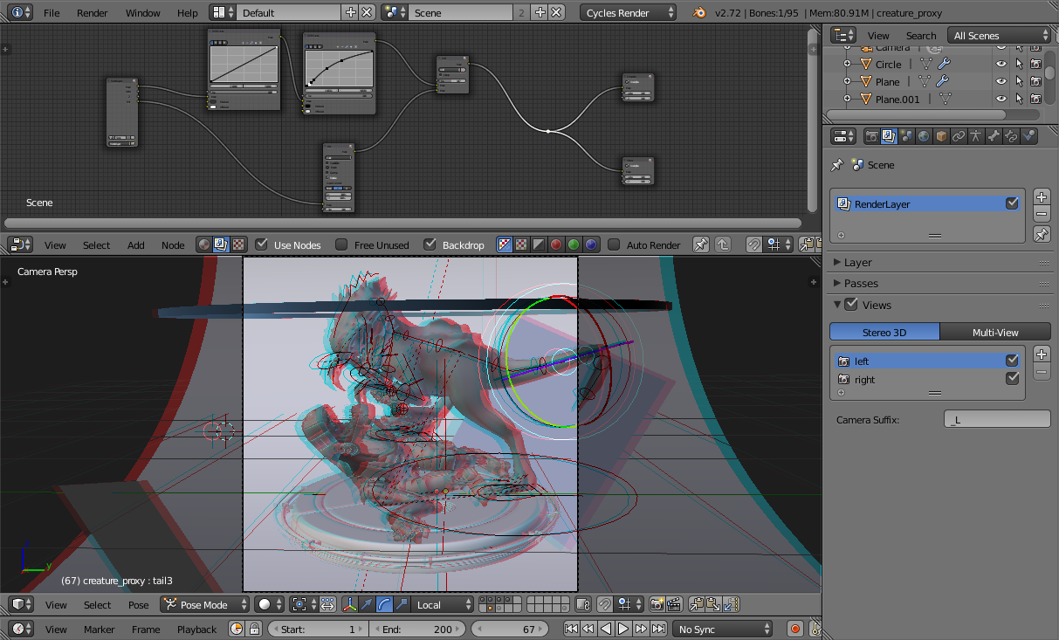
Since version 2.75, Blender has come with a new feature called Multiview. Multiview is a complete toolset for working with stereoscopic rendering in Blender. It works with both the Blender Internal and Cycles rendering engines and it also supports many different stereo 3D visualization types.

Note
If you have a real 3D display at some point you can change the 3D display mode in the Window menu, by calling the Stereo 3D operator. Be aware that some modes require a fullscreen editor to work, and this can be taxing on your CPU.

Usage

For example, we will take an existing blend file that was made for monoscopic rendering and transform it to be stereo 3D ready.
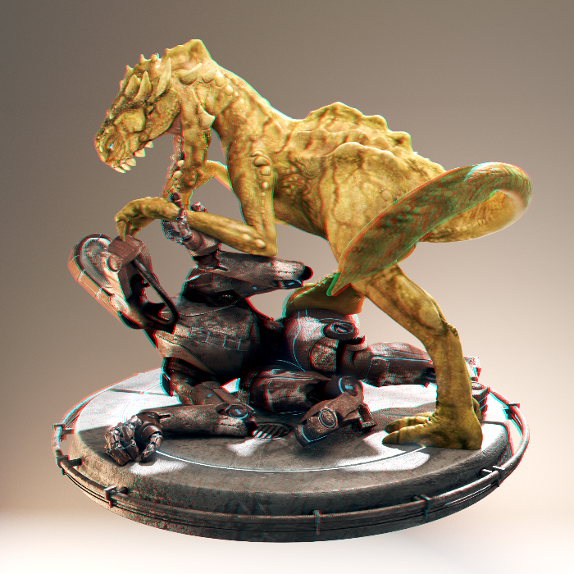
Creature Factory 2 by Andy Goralczyk Rendered in Stereo 3D (anaglyph).

Note
Multi-View drawing requires capable graphics card and drivers with Triple Buffer support. If the Automatic mode does not work, set the Window Draw Method in the System User Preferences.

Introduction
Start opening up your project file, in this case turntable.blend from the Creature Factory 2 Open Movie Workshop series from the Blender Institute by Andy Goralczyk.
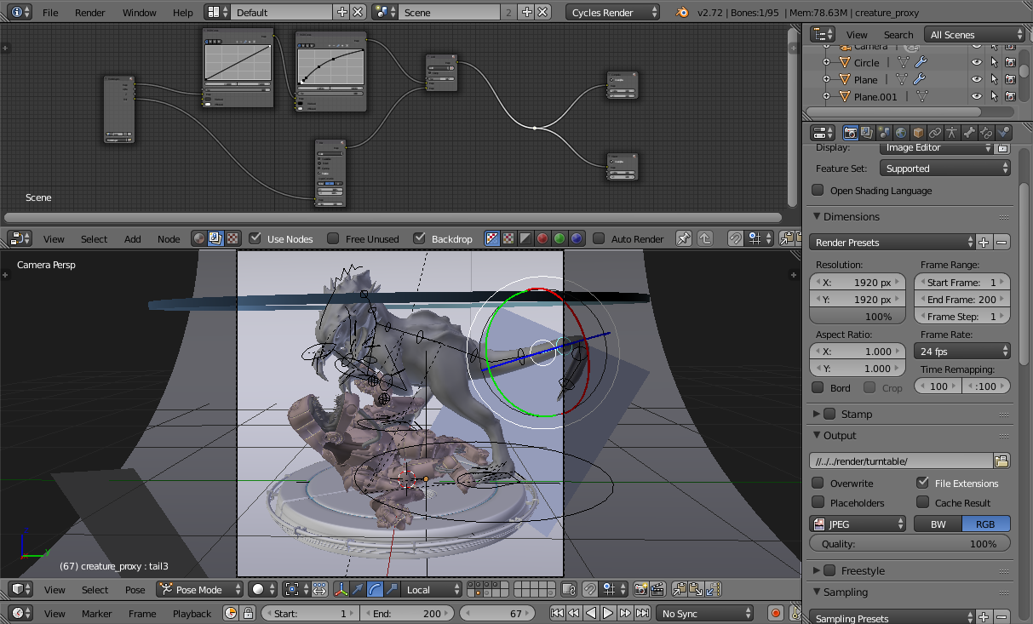
Turn Table Creature Factory 2.

Views Setup
Go to the Render Layers panel and enable Views for this scene.
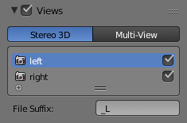
Scene Render Views.
Note
When you turn on Views in the scene, you get 3D preview in the viewport, as well as multiple panels that are now accessible all over the user interface.

Viewport with 3D visualization.

Camera
To tweak the stereo 3D parameters, select the camera in the Outliner. In the Camera panel go to the Stereoscopy tab and change the Convergence Distance.
The viewport will respond in real-time to those changes allowing you to preview the current depth value of the scene.
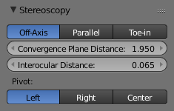
Stereo Convergence Distance.

Viewport
Before fine-tuning the camera parameters, you can set the convergence plane in the viewport based in your scene depth layout. Go outside the camera view and you will instantly see the convergence plane in front of the camera.
You can toggle this and other display settings in the Stereoscopy panel of the 3D Views properties region. In the following image, the camera’s frustum volumes are also visible.
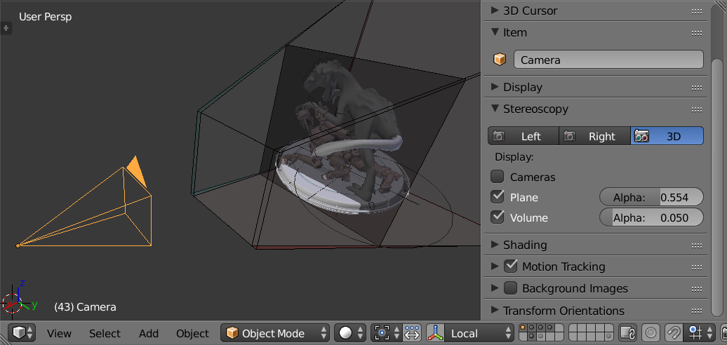
Viewport Plane and Volume Stereo Preview.

Stereo 3D Display
If you have a real 3D display at some point, you can change the 3D display mode in the Window menu, by calling the Stereo 3D operator. Be aware that some modes require a fullscreen editor to work.
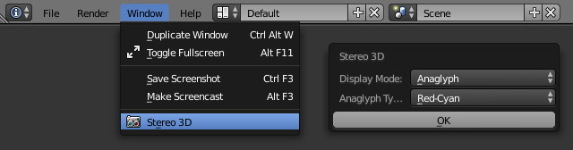
Window Menu, Stereo 3D Operator.

OpenGL Preview
Before rendering your scene, you can save an OpenGL preview of the animation for testing in the final display. In the Render Output panel you can choose the output Views Format.
The options include individual files per view, top-bottom, anaglyph among others. Pick the one that fits your display requirements.

Rendering and UV/Image Editor
Once you are happy with the results, you can render out the final animation. In the UV/Image Editor you can inspect the individual views and the stereo result.

Image Formats
Your final animation can be saved in more robust formats than the ones used by the OpenGL render preview. In this example we saved as cross-eyed side-by-side stereo 3D.
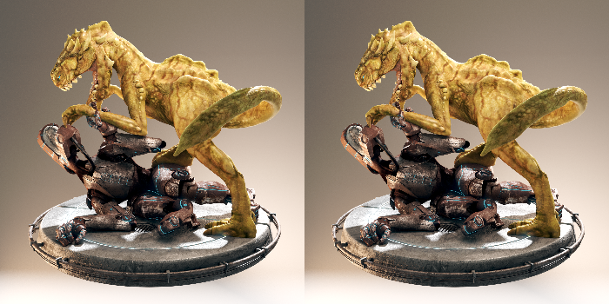
Side by Side Cross-Eye Format.

Final Considerations
As this guide showed, there is more to stereo 3D rendering than just generate two images. The earlier the stereo pipeline is considered the smoother it will get. The following sections are a more in-depth view of the individual components we visited in the workflow.

Window Stereo 3D Display
An essential component of the Stereoscopy pipeline is the ability to display the stereo image in a proper display. Blender supports from high-end 3D displays to simple red-cyan glasses. On top of that, you can set a different display mode for each window.
The display mode can be changed via the Window menu or if you create your own shortcuts for the wm.set_stereo_3d operator.
Window Menu, Stereo 3D Operator.

Display Mode
Anaglyph
Render two differently filtered colored images for each eye. Anaglyph glasses are required. We support Red-Cyan, Green-Magenta and Yellow-Blue glasses.
Interlace
Render two images for each eye into one interlaced image. A 3D-ready monitor is required. We support Row, Column and Checkerboard Interleaved. An option to Swap Left/Right helps to adjust the image for the screen. This method works better in fullscreen.
Time Sequential
Render alternate eyes. This method is also known as Page Flip. This requires the graphic card to support Quad Buffer and it only works in fullscreen.
Side-by-Side
Render images for left and right eye side-by-side. There is an option to support Cross-Eye glasses. It works only in fullscreen, and it should be used with the Full Editor operator.
Top-Bottom
Render images for left and right eye one above another. It works only in fullscreen, and it should be used with the Full Editor operator.

Note
Full Screen Stereo 3D Modes
If you have a 3D display most of the time, you will use it to see in stereo 3D, you will have to go to the fullscreen mode. In fact some modes will only work in the full window mode that hides most of the user interface from the work area. In this case it is recommended to work with two monitors, using the 3D screen for visualizing the stereo result while the other screen can be used for the regular Blender work.

Stereo 3D Camera
When using the Stereo 3D scene view setup, a stereo pair is created on-the-fly and used for rendering and previsualization. For all the purposes this works as two cameras that share most parameters (focal length, clipping, …). The stereo pair, however, is offsetted, and can have unique rotation and shift between itself.
Stereo 3D Camera Settings.
Interocular Distance
Set the distance between the camera pair. Although the convergence of a stereo pair can be changed in post-production, different interocular distances will produce different results due to the parts of the scene being occluded from each point of view.
Convergence Plane Distance
The converge point for the stereo cameras. This is often the distance between a projector and the projection screen. You can visualize this in the 3D View.

Convergence Mode
Off-Axis
The stereo camera pair is separated by the interocular distance, and shifted inwards so it converges in the convergence plane. This is the ideal format since it is the one closest to how the human vision works.
Parallel
This method produces two parallel cameras that do not converge. Since this method needs to be manually converged it cannot be used for viewing. This method is common when combining real footage with rendered elements.
Toe-in
A less common approach is to rotate the cameras instead of shifting their frustum. The Toe-in method is rarely used in modern 3D productions.
Pivot
The stereo pair can be constructed around the active camera with a new camera built for each eye (Center Pivot) or using the existing camera and creating (Left or Right). The latter is what is used when only one eye needs to be rendered for an existing mono 2D project.

Viewport Stereo 3D
When you enable ‘Views’ in the Render Layer panel, a new area is available in the 3D View properties region. In this panel you can pick whether to see the stereo 3D in the viewport, or which camera to see. It also allow you to see the Cameras, the Plane and the Volume of the stereo cameras.
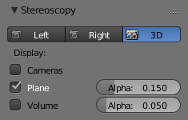
Viewport Stereo 3D Settings.
Cameras
When working with the Stereo 3D Views setup, you can inspect what each individual generated camera is looking or the combined result of them. In the Multi-View mode you can see the combined result of the left and right cameras (when available) or the current selected camera.
Plane
The convergence plane represents the screen as it is perceived by the audience. Visualizing it in the 3D View allows you to layout your scene based on your depth script outside the camera view.
Volume
The intersection of the stereo cameras frustums helps planning the show by avoiding elements being visible by only one camera. The volume is defined by the camera’s start and end clipping distances. The areas that are in the frustum of one camera only are known as retinal rivalry areas. They are tolerated in the negative space (the region from the convergence plane into the image) but are to be avoided at all costs in the positive space (the area from the convergence plane to the camera).
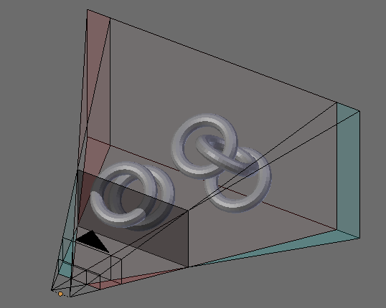
Viewport 3D: Convergence Plane and Volume Display.

Multi-View and Stereo 3D Image I/O
Multi-View and Stereo 3D
Multi-View images can be saved in special formats according to the production requirements. By default the system saves each view as an individual file, thus generating as many files as views to be rendered. In stereo 3D productions, for the final deployment or even intermediary previews it is convenient to save stereo 3D images, that are ready to use with 3D displays or simple anaglyph glasses. The formats supported match the display modes available for the window.
Lossy-Formats
Some stereo 3D formats represent a considerable loss of data. For example, the Anaglyph format will cap out entire color channels from the original image. The Top-Bottom compressed will discard half of your vertical resolution data. The Interlace will mash your data considerably. Once you export in those formats, you can still import the image back in Blender, for it to be treated as Stereo 3D. You will need to match the window stereo 3D display mode to the image stereo 3D format though.
Lossless Formats
Some formats will preserve the original data, leading to no problems on exporting and importing the files back in Blender. The Individual option will produce separate images that (if saved in a lossless encoding such as PNG or OpenEXR) can be loaded back in production with no loss of data. For the Stereo 3D formats the only lossless options are Top-Bottom and Side-by-Side without the Squeezed Frame option.
Multi-View OpenEXR
Another option is to use Multi-View OpenEXR files. This format can save multiple views in a single file and is backward compatible with old OpenEXR viewers (you see only one view though). Multi-View native support is only available to OpenEXR.

Image Editor
View Menu
After you render your scene with Stereo 3D you will be able to see the rendered result in the combined stereo 3D or to inspect the individual views. This works for Viewer nodes, render results or opened images.
Stereo 3D and View menu.
Views Format
When you drag and drop an image into the UV/Image Editor, Blender will open it as an individual images at first. If your image was saved with one of the Stereo 3D formats, you can change how Blender should interpret the image by switching the mode to Stereo 3D, turning on Use Multi-View and picking the corresponding stereo method.
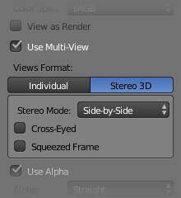
Views Formats and Stereo 3D.

Compositor
The compositor works smoothly with Multi-View. The compositing of a view is completed before the remaining views start to be composited. The pipeline is the same as the single-view workflow, with the difference that you can use Images, Movies or Image Sequences in any of the supported Multi-View formats.
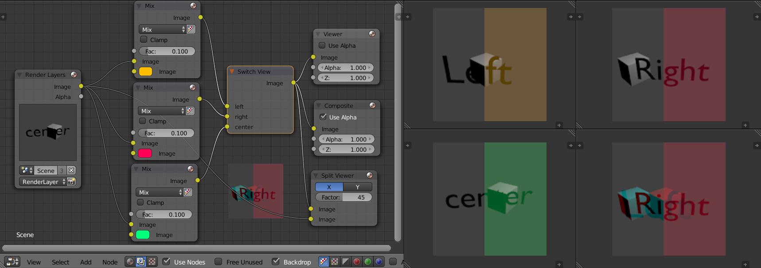
Compositor, Backdrop and Split Viewer Node.
The views to render are defined in the current scene views, in a similar way as you define the composite output resolution in the current scene render panel, regardless of the Image nodes resolutions or Render Layers from different scenes.
Note
Single-View Images
If the image from an Image Node does not have the view you are trying to render, the image will be treated as a single-view image.

Switch View Node
If you need to treat the views separately, you can use the Switch View node to combine the views before an output node.

Performance Tip
By default, when compositing and rendering from the user interface all views are rendered and then composited. During test iterations you can disable all but one view from the Scene Views panel, and re-enable it after you get the final look.

